**Turdalin Nurassyl LAB4**

**7.2.7**

1. Изображение выглядит как текст

   Автоматически созданное описание
2. Изображение выглядит как стол

   Автоматически созданное описание
3. OUI: 3C-9C-0F
4. SN: B8-87-E7
5. 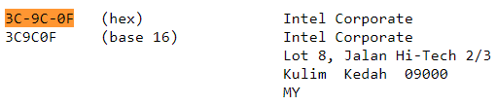
6. OUI: 000142
7. SN: DC291A
8. 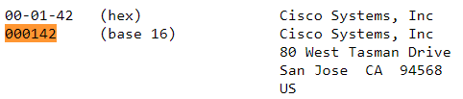
9. MAC for VLAN 1 on S1: 0004.9ae9.62c6
10. E9-62-C6
11. If assigned by the device manufacturer, such as Shure, a MAC **address** usually encodes the manufacturer's registered identification number and may be referred to as the **burned-in address** (BIA).
12. The MAC address can be changed via a software command. The actual address (bia) will still be there. It is shown in the parenthesis.
13. 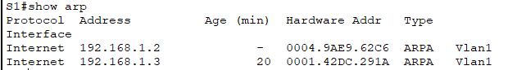
14. Layer 2: MAC addresses
15. Layer 3: IP addresses
16. Изображение выглядит как текст

    Автоматически созданное описаниеFast Ethernet 1
17. ARP can be example of broadcasts at Layer 2. MAC will be: FF:FF:FF:FF:FF:FF
18. Device can change his IP address, but not MAC. Because MAC address is physical address of NIC of device.